| **Name of Student:** Ajay Karthikesan | | | |
| --- | --- | --- | --- |
| **Roll Number:** 57 | | **Practical Number:** 8 | |
| **Aim of Practical:**  To Write a program to record and pay audio, play video and use GPS.  A) Record an audio and play  B) Play a video in Videoview.  C) Display the current location of your device (Latitude & Longitude). | | | |
| **DOP:** - | | **DOS:** 31.10.23 | |
| **CO Mapped:** - | **PO Mapped:** - | **Faculty Signature:** | **Marks:** |

## 

## Practical No. 8

**Aim:** To Write a program to record and pay audio, play video and use GPS.

A) Record an audio and play

B) Play a video in Videoview.

C) Display the current location of your device (Latitude & Longitude).

**Theory:**

VideoView:

Displays a video file. The VideoView class can load images from various sources (such as resources or content providers), takes care of computing its measurement from the video so that it can be used in any layout manager, and provides various display options such as scaling and tinting.

Note: VideoView does not retain its full state when going into the background. In particular, it does not restore the current play state, play position, selected tracks, or any subtitle tracks added via addSubtitleSource(). Applications should save and restore these on their own in Activity.onSaveInstanceState(Bundle) and Activity.onRestoreInstanceState(Bundle).

Also note that the audio session id (from getAudioSessionId()) may change from its previously returned value when the VideoView is restored.

By default, VideoView requests audio focus with AudioManager#AUDIOFOCUS_GAIN. Use setAudioFocusRequest(int) to change this behavior.

The default AudioAttributes used during playback have a usage of AudioAttributes#USAGE_MEDIA and a content type of AudioAttributes#CONTENT_TYPE_MOVIE, use setAudioAttributes(android.media.AudioAttributes) to modify them.

Summary

**Code:**

File: MainActivity.java

package vesit.ajayk57.mc.practical8;

import androidx.appcompat.app.AppCompatActivity;

import android.content.Intent;

import android.os.Bundle;

public class MainActivity extends AppCompatActivity {

@Override

protected void onCreate(Bundle savedInstanceState) {

super.onCreate(savedInstanceState);

setContentView(R.layout.activity_main);

findViewById(R.id.runA).setOnClickListener(view -> startActivity(

new Intent(this, ProblemAActivity.class)

));

findViewById(R.id.runB).setOnClickListener(view -> startActivity(

new Intent(this, ProblemBActivity.class)

));

findViewById(R.id.runC).setOnClickListener(view -> startActivity(

new Intent(this, ProblemCActivity.class)

));

}

}

File: activity_main.java

<?xml version="1.0" encoding="utf-8"?>

<androidx.constraintlayout.widget.ConstraintLayout xmlns:android="http://schemas.android.com/apk/res/android"

xmlns:app="http://schemas.android.com/apk/res-auto"

xmlns:tools="http://schemas.android.com/tools"

android:layout_width="match_parent"

android:layout_height="match_parent"

tools:context=".MainActivity">

<TextView

android:id="@+id/main_title"

android:layout_width="wrap_content"

android:layout_height="wrap_content"

android:layout_marginTop="16dp"

android:text="@string/practical_num_8"

android:textSize="20sp"

android:textStyle="bold"

app:layout_constraintBottom_toBottomOf="parent"

app:layout_constraintEnd_toEndOf="parent"

app:layout_constraintStart_toStartOf="parent"

app:layout_constraintTop_toTopOf="parent"

app:layout_constraintVertical_bias="0.0" />

<Button

android:id="@+id/runA"

android:layout_width="wrap_content"

android:layout_height="wrap_content"

android:layout_marginTop="8dp"

android:text="@string/problemA"

app:layout_constraintBottom_toBottomOf="parent"

app:layout_constraintEnd_toEndOf="parent"

app:layout_constraintHorizontal_bias="0.5"

app:layout_constraintStart_toStartOf="parent"

app:layout_constraintTop_toBottomOf="@+id/main_title"

app:layout_constraintVertical_bias="0.25" />

<Button

android:id="@+id/runB"

android:layout_width="wrap_content"

android:layout_height="wrap_content"

android:layout_marginTop="8dp"

android:text="@string/problemB"

app:layout_constraintEnd_toEndOf="parent"

app:layout_constraintHorizontal_bias="0.5"

app:layout_constraintStart_toStartOf="parent"

app:layout_constraintTop_toBottomOf="@+id/runA" />

<Button

android:id="@+id/runC"

android:layout_width="wrap_content"

android:layout_height="wrap_content"

android:layout_marginTop="8dp"

android:text="@string/problemC"

app:layout_constraintBottom_toBottomOf="parent"

app:layout_constraintEnd_toEndOf="parent"

app:layout_constraintHorizontal_bias="0.5"

app:layout_constraintStart_toStartOf="parent"

app:layout_constraintTop_toBottomOf="@+id/runB"

app:layout_constraintVertical_bias="0.0" />

</androidx.constraintlayout.widget.ConstraintLayout>

**Output:**

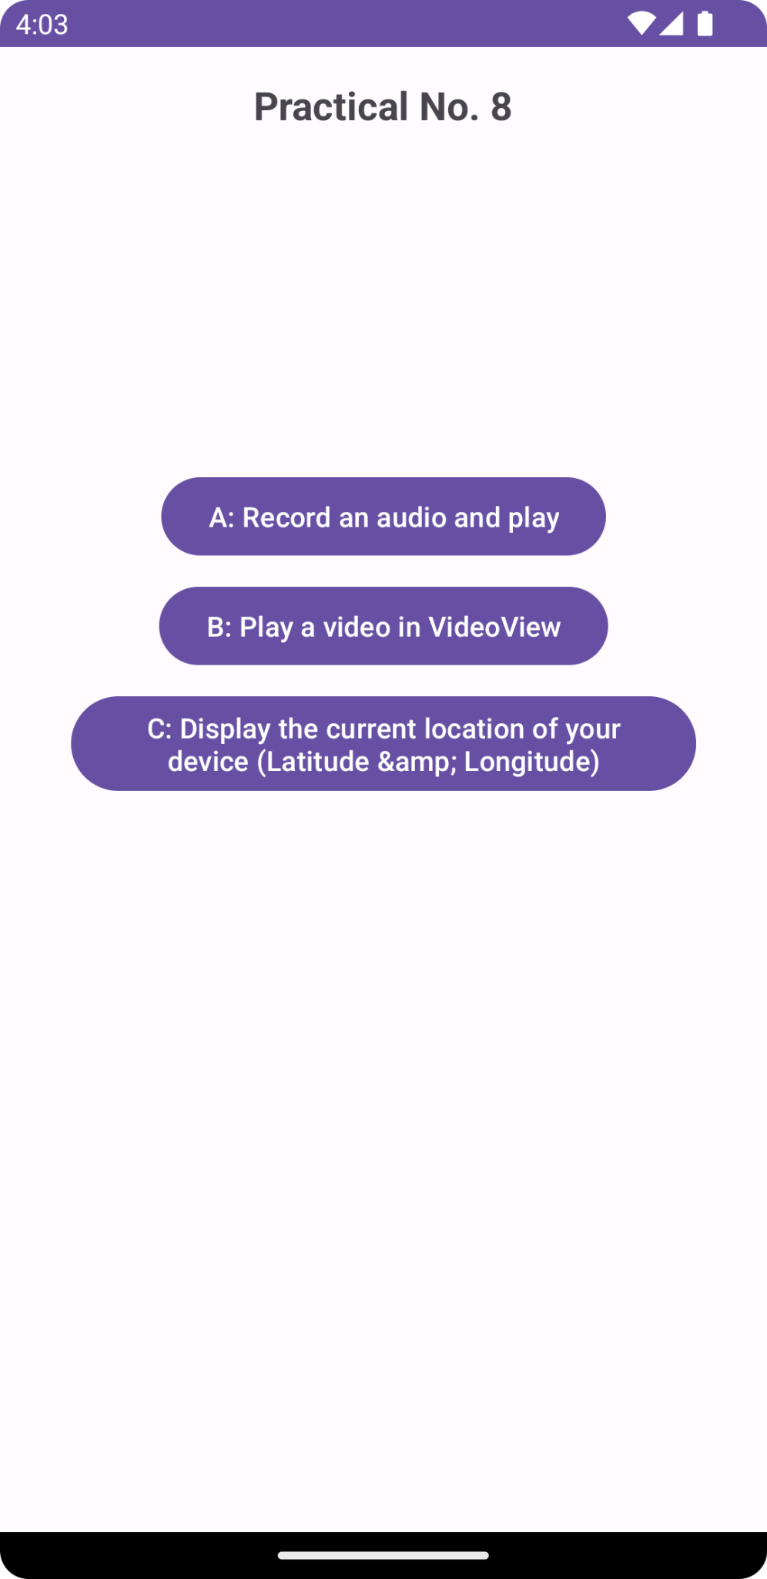

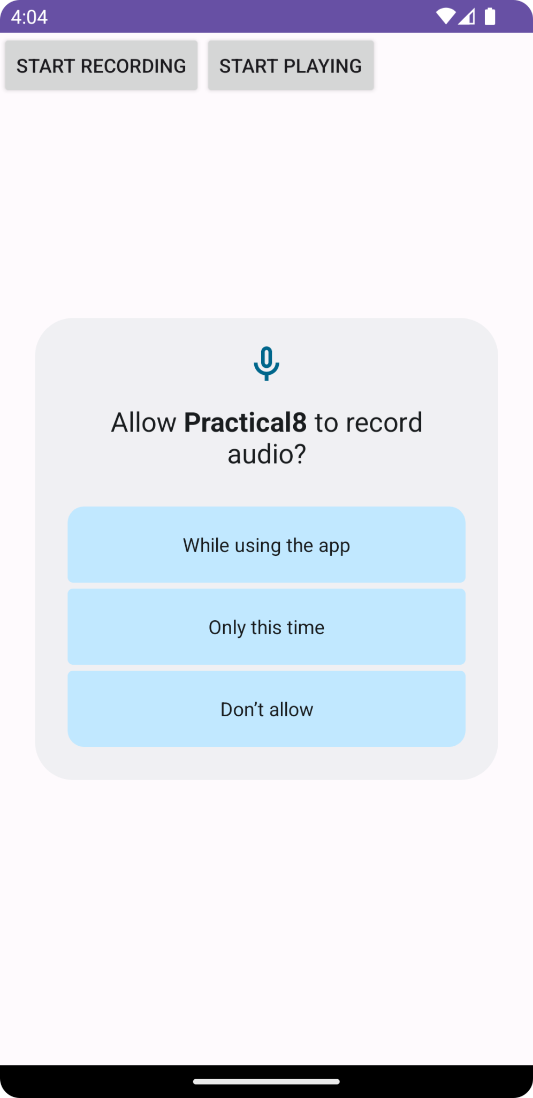

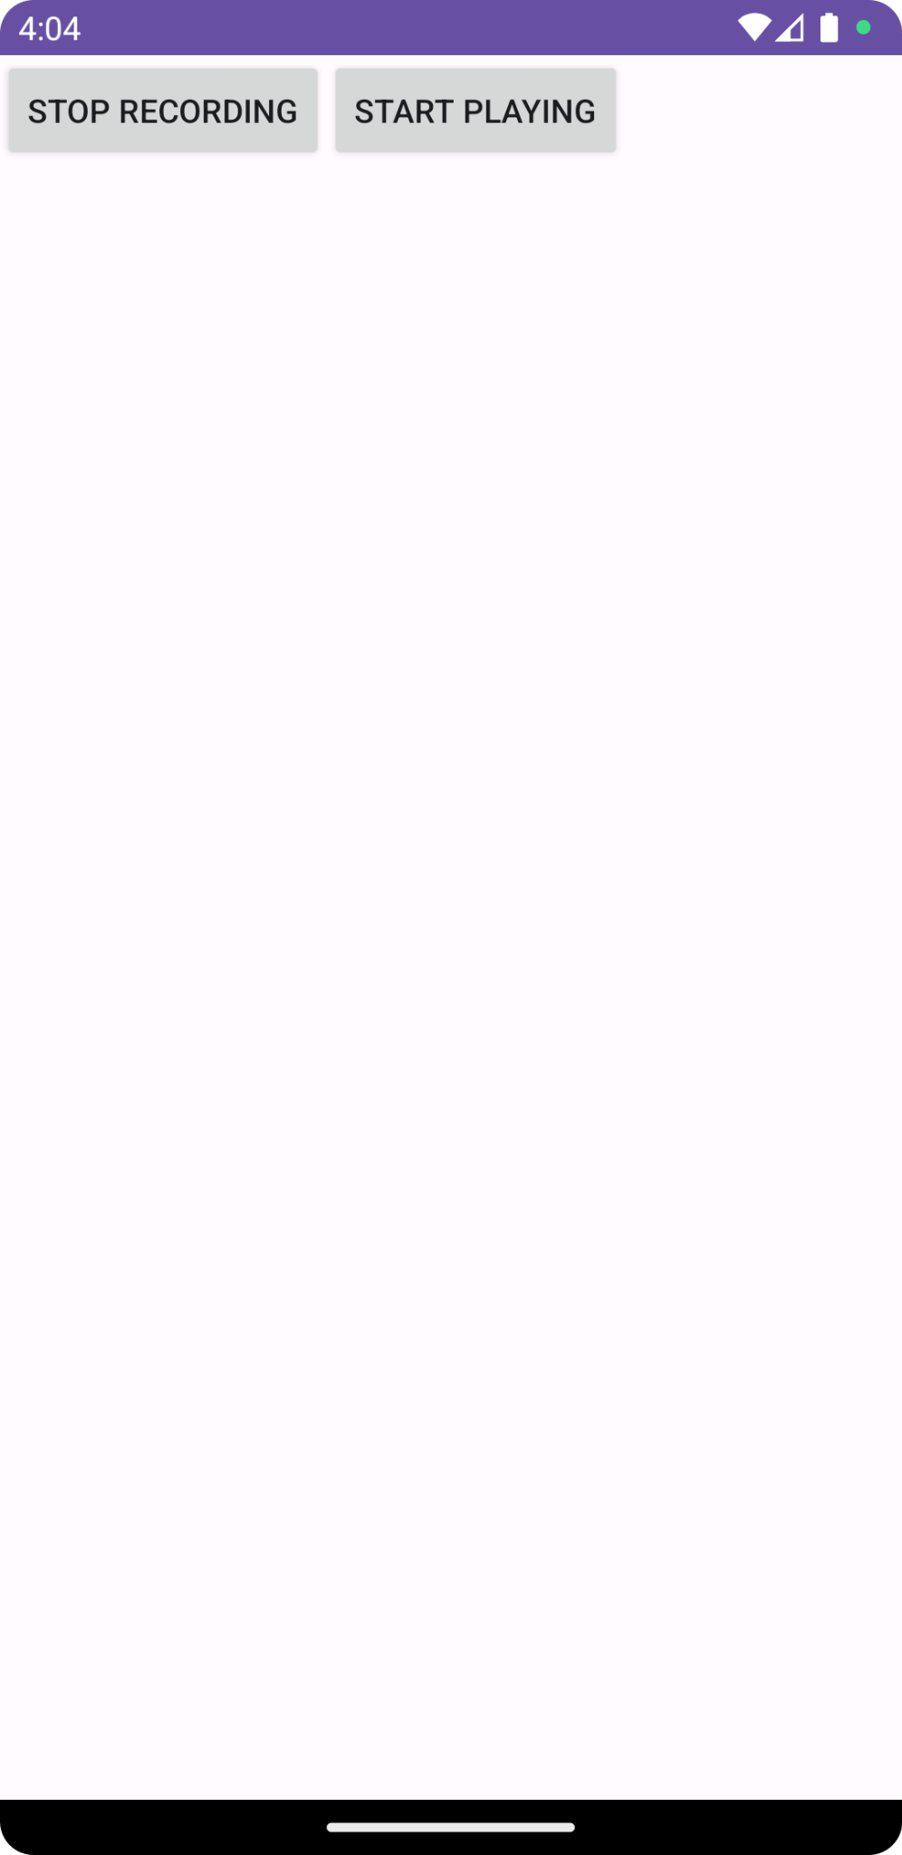

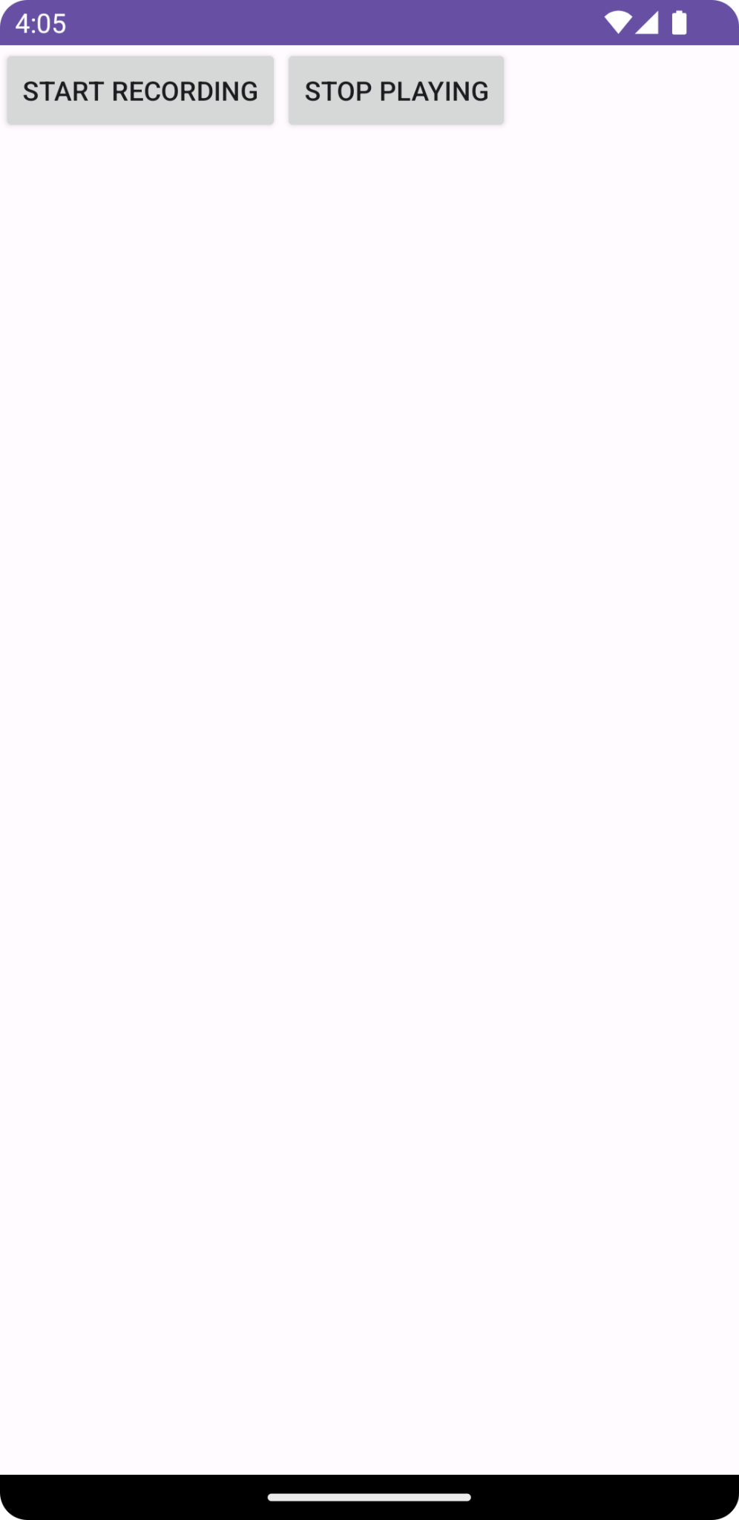

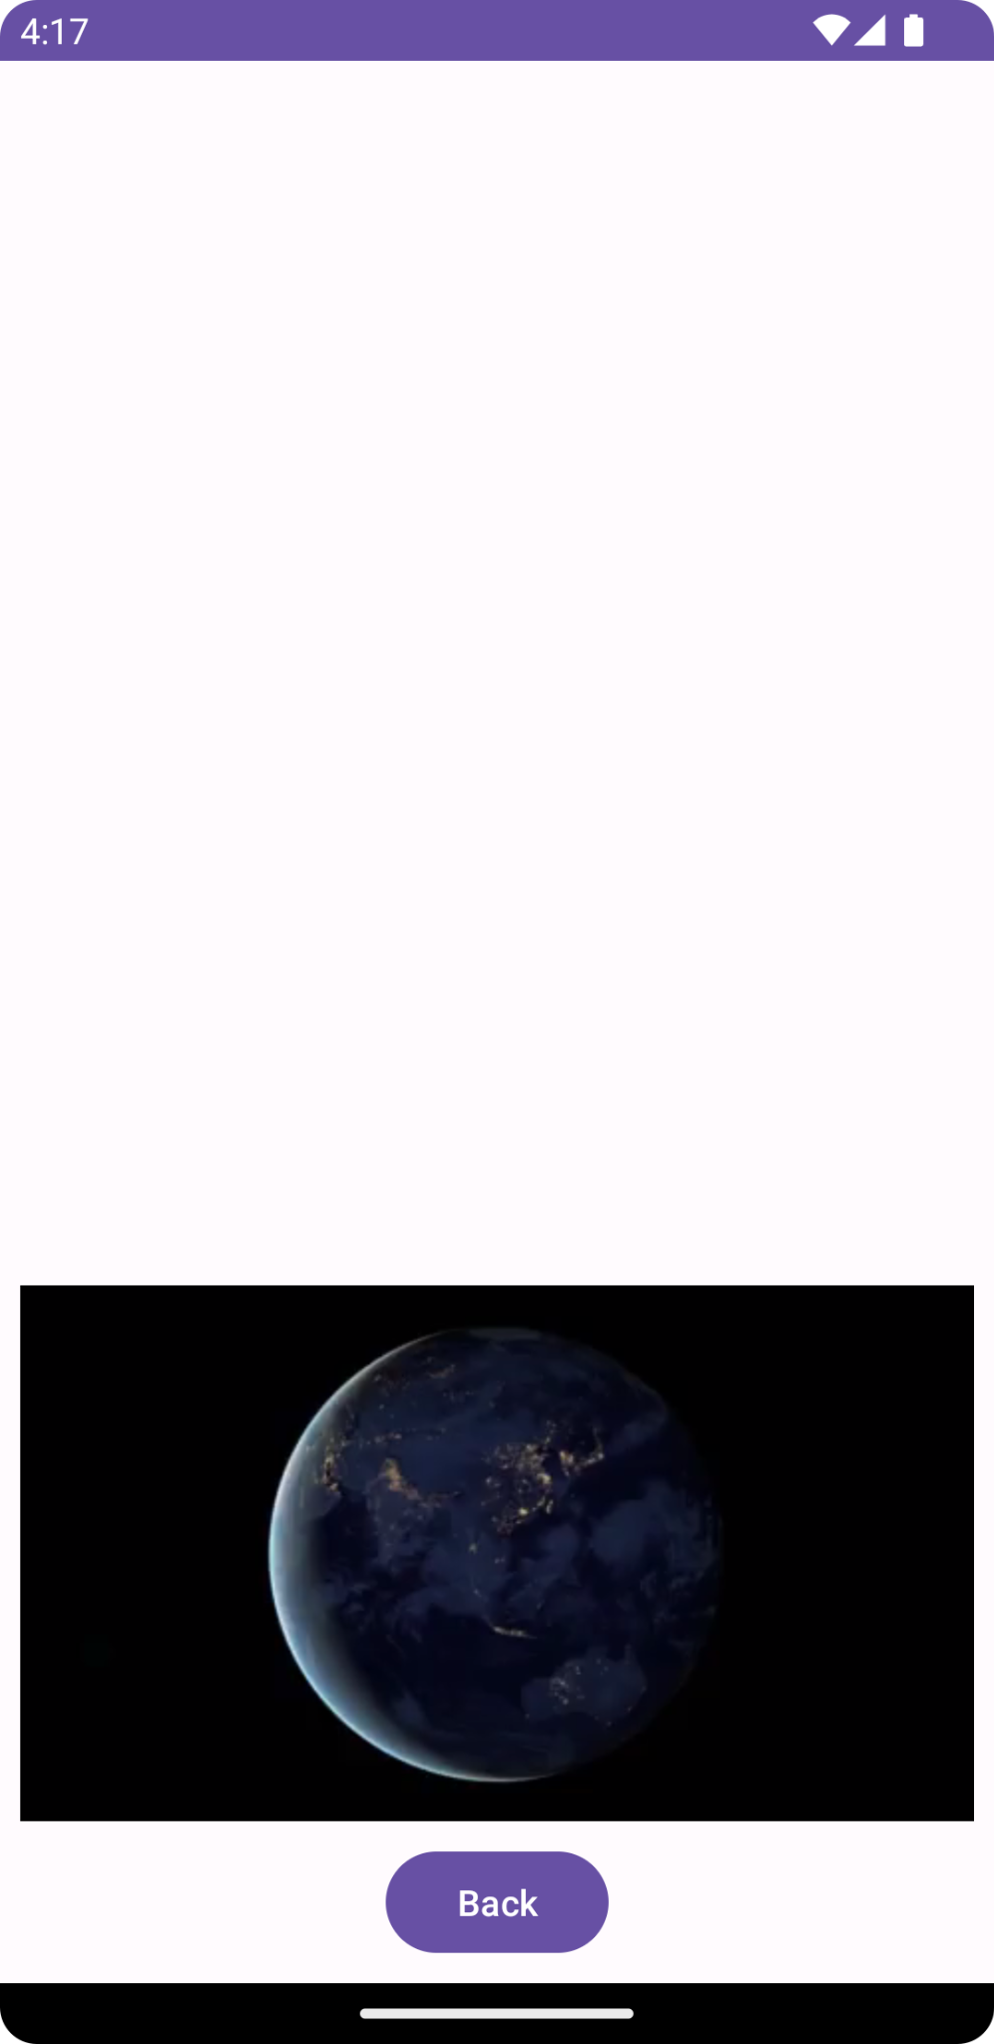

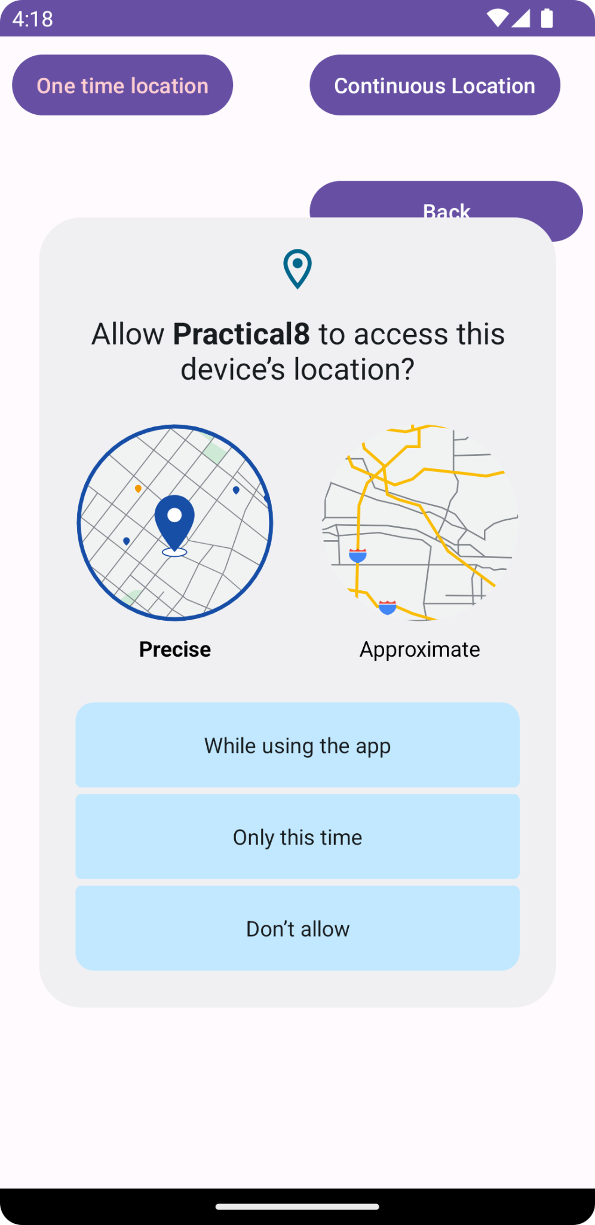

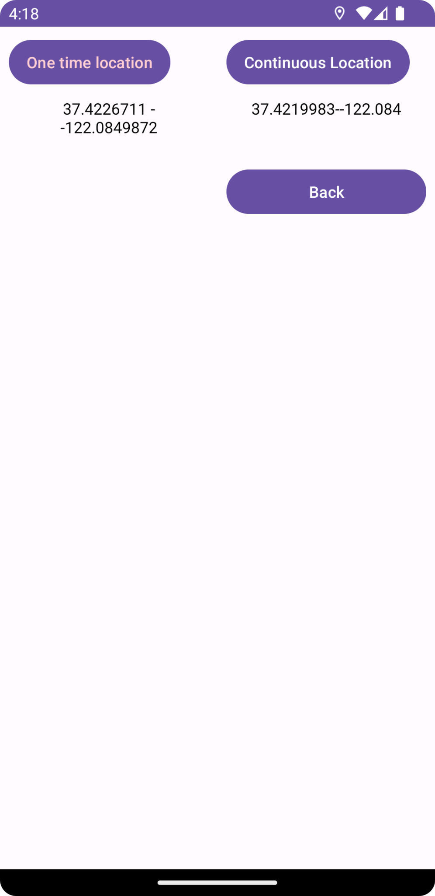

**Conclusion:**

I learnt how to write a program to record and pay audio, play video and use GPS.